15.60: a)

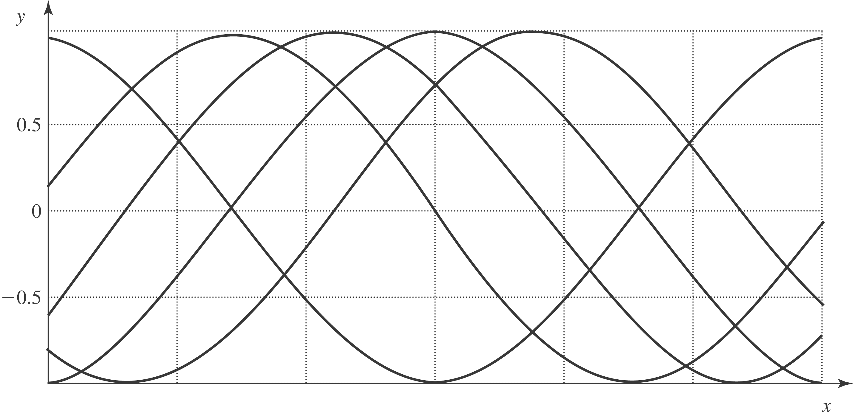
b) would both give 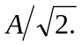 If the particle is known to be moving downward, the result of part b) shows that 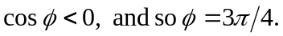 d) To identify uniquely, the quadrant in which is must be known. In physical terms, the signs of both the position and velocity, and the magnitude of either, are necessary to determine (within additive multiples of 

